Scouts BSA Troop 234

Meets Mondays at 6:30-8:00 pm

St Joseph Catholic Church
1200 Cornelia Rd
Anderson, SC 29621

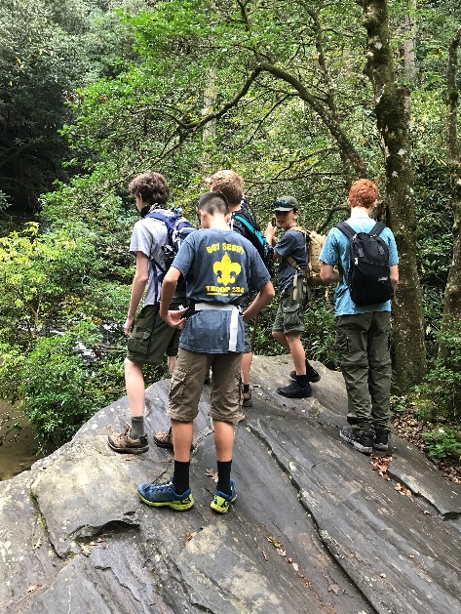

Sponsored by the Knights of Columbus, our troop was formed in 2012. As of Dec 2020, we have had 8 Scouts earn their Eagle. We offer a range of programs for boys ages 11 to 17 including outdoor activities, merit badge classes, service projects, and leadership opportunities.
Youth and adults are always welcome to visit and see what we are all about!

Contact Scoutmaster Chris Luplow
864-356-1524
luplowc@gmail.com

or visit our website
Troop234sc.weebly.com

