Troop 234 Open House

St Joseph Catholic Church
1200 Cornelia Rd
Anderson, SC 29621

Monday, September 27
6:30-8:00 pm

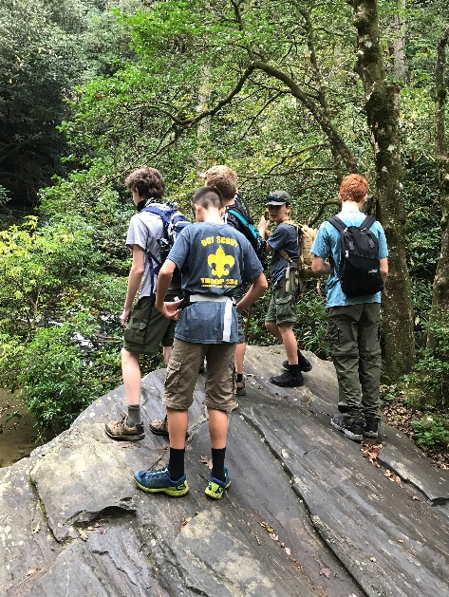

Youth will get to meet and interact with our Scouts.
Our adult leaders will discuss Scouting, how a troop operates, and answer questions

Questions?
Contact Scoutmaster Chris Luplow
864-356-1524
luplowc@gmail.com

Troop234sc.weebly.com

