New Parent’s Guide

Troop 234

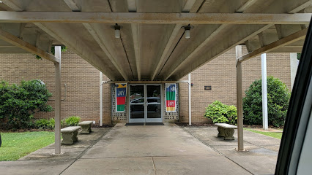

Meets Mondays at 6:30-8:00 pm

St Joseph Catholic Church
1200 Cornelia Rd
Anderson, SC 29621

Troop234sc.weebly.com
WELCOME TO TROOP 234!

Sponsored by the Knights of Columbus, our troop was formed in 2012. As of Dec 2020, we have had 8 Scouts earn their Eagle. We offer a range of programs for boys ages 11 to 17 including outdoor activities, merit badge classes, service projects, and leadership opportunities. We recognize that, when you first join, it can be intimidating. There is a bit of a learning curve, whether your son was in Cub Scouts or is just starting. This guide was created to address many of the issues that will come up in your first year.

Finding and Joining a BSA Troop

You are encouraged to visit as many troops in your area as possible. We have many differences such as meeting time, troop size, and resources. Give your son the opportunity to find a unit he feels best meets his interests. No previous Scouting experience is required. Youth can join Scouts BSA if they have completed the fifth grade and are at least 10 years old, OR have earned the Arrow of Light Award and are at least 10 years old, OR are age 11 but have not reached age 18.

Scouting has no off season! If your son is involved in sports, band, or other extracurricular activities, that is great. There are awards he can earn toward each of them, but he can still be in Scouting when he is able.

Once your Scout joins a troop, commit fully and get involved yourself. Every troop can use an additional helping hand.

Parent participation is important in order to have the most impact on your son’s time in Scouting! The journey is filled with adventure and learning. Shared with other adults in the troop, this journey can be one of the most treasured experiences you will have.

The Difference between Cub Scouts and Scouts BSA

Cub Scouts:
Come in as a boy, leave as a boy
Adult led
Involves supervised activities

Scouts BSA:
Come in as a boy, leave as a young man
Scout led, adult advised
Involves activities requiring greater degrees of self-supervision

IMPORTANT TROOP 234 RULES

No unkind words!

No unkind or inappropriate touches!

Respect other’s personal property!

Scouts turn in electronic devices when you arrive!

These rules are intended to ensure that Troop 234 is a safe and comfortable place for all Scouts, parents, and leaders. Failure to follow these rules, or otherwise acting in a non-scout-like manner, will result in suspension from troop activities for a period of time to be determined by the Troop Committee Chair and the Scoutmaster. A single severe infraction or repeated non-scout-like actions will result in more severe consequences including possibly a requirement for a parent to be present at all times or even expulsion from Troop 234.

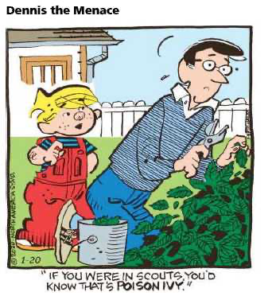
YOUR ROLE AS A SCOUTING PARENT

Stay Informed

We are a very active troop. Most young Scouts cannot hope to keep track of all the events going on. We recommend that parents:

- Talk to your son
- Meet and converse with other parents and leaders
- Attend the beginning or end of troop meetings when announcements are made
- Review sign-up sheets and flyers located inside the meeting room
- Read the Troop 234 Upcoming Events newsletter emailed monthly
- Read any email updates provided during the month
- Get logged into Scoutbook.com and keep your contact information up to date

Encourage, Support, and Engage

- Read your Scout’s Handbook and understand the purpose and methods of Scouting
- Actively follow your Scout’s progress, offer encouragement, and push when needed
- Show support to your Scout and the troop by attending the Troop Courts of Honor
- Assist and encourage your Scout to participate in troop fundraisers and service opportunities
- Be aware of your Scout’s leadership or patrol level responsibilities

How Can I Be Involved?

- Take Youth Protection Training (https://www.scouting.org/training/youth-protection/)
- Be an Assistant Scoutmaster (ASM)
- Be a Committee Member
  - Advisor for boys in troop positions
  - Board of Review Committee
- Drive to/from an event
- Be an “adult in charge” for an event
- Be a Merit Badge Counselor

UNIFORM & EQUIPMENT

What Do I Buy?

- Boy Scout Handbook (issued by troop); this should be brought to every meeting

- Scouts BSA Uniform Shirt with appropriate insignia, patches, and troop numerals (proper insignia location can be found in the Scout Handbook or at the link listed later)
  - World Crest Scout and Ring Emblems

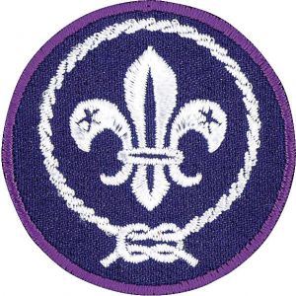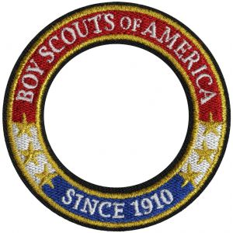

  - Council Patch
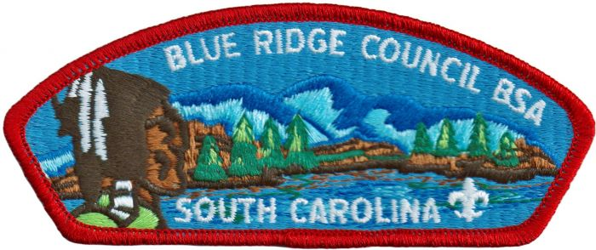

  - Troop Numeral Patch(es) (issued by troop)
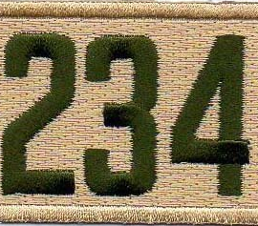
  - Scouts BSA Shoulder Loops (issued by troop)
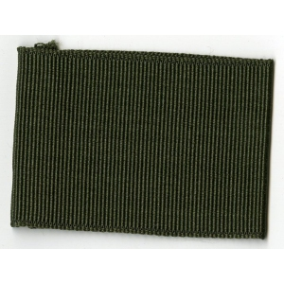
  - Scouts BSA Merit Badge Sash
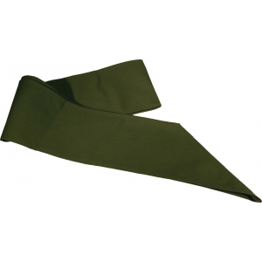
- Scouts BSA Pants or similar green cargo pants
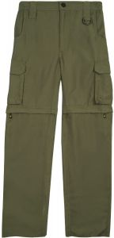
- BSA Activity Uniform (Class B T-Shirt) – we will periodically order these during the year; at campouts, you may wear any BSA approved shirt when we ask the Scouts to wear this uniform (pack t-shirts, summer camp shirts)
- Sneakers or hiking shoes – comfort is the most important factor, but something that will protect the Scout’s foot from blisters, mud, and roots while hiking or camping is a must
- Hydration pack – basically a small backpack with a removable reservoir; recommend reservoirs of 1.5 liters minimum, 2-2.5 is good for almost all hiking and outdoor activities; bag size of at least 10 liters will allow your Scout to pack lunch, snacks, and an extra layer
- Sleeping bag – 30 degree, synthetic; temperature rating is survival only, not comfort; in cooler weather (below 55), he will need a liner or blanket
- Rain coat and pants – it is going to rain on your Scout at some point; good rain gear is essential to preventing a weekend disaster

Consider

- Cover for the Scout Handbook to keep it from getting wet or damaged
  - The Scout Shop sells Scouts the BSA Handbook Cover for $10
- Clothing that wicks away moisture (synthetics like polyester and nylon, not cotton); cotton holds moisture and loses its ability to insulate
- Sleeping pad – comfort and heat loss prevention; ¾ length or full
- Headlamp – setting up camp, washing dishes, or walking through camp is easier to do in the dark with both your hands free
- Compass – several merit badges are going to require the use and knowledge of a compass
  - Suunto A-10 is under $20
- Mess kit: personal cup, bowl, fork and spoon – for backpacking
  - Walmart sells the Ozark Trail 2 person table set for $7

Optional

- Hat – not required, but if one is worn, it should be a BSA approved Scout hat
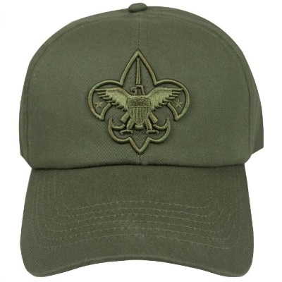

Things to Think About

- The most expensive item isn’t always the best; new ultralight backpacking gear may be no good if your Scout doesn’t like camping
- Camping equipment changes over time with new technology; sometimes a $5 item works just as well as a $50 one; ask the leaders or other parents if you are unsure
- All of your Scout’s personal gear should be labeled!

What Not to Buy

- Cooking gear
  - each patrol has a chuck box which holds cookware, kitchen utensils, plates, and eating utensils
  - the troop has stoves, ovens, and propane

TROOP MEETINGS

Organized Chaos

- Meetings are held every Monday from 6:30 to 8:00 pm, unless otherwise noted; try to arrive 5 to 10 minutes before that time, so the Scouts can prepare for the opening which happens at 6:30 sharp!

- Scouts should wear their Scouts BSA Uniform Shirt along with Scouts BSA Pants or similar green cargo pants/shorts; this is the uniform they should always wear unless told otherwise; they should also always bring their Scout Handbook

- The third Monday of the month is for the PLC (Patrol Leaders Council); Scouts with troop positions and all patrol leaders attend

The Meeting

- Gather in the Parish Hall

- Turn in electronic devices!

- Boys will form a circle in front of the flags with a patrol leader centered

- The patrol leader (or whoever he designates) leads the troop in the Pledge of Allegiance, Scout Oath, Scout Law, and Outdoor Code

- Announcements are made

- Scouts are dismissed to their patrols to work on rank advancement, sign up and plan for future activities, work on merit badges, and participate in a Scoutmaster conference or Board of Review

- Patrol games

- Around 7:45 pm, Scouts will circle up for announcements and reminders

- Dismiss with The Scoutmaster Benediction

The Scoutmaster Benediction

“And now may the Great Scoutmaster of all true Scouts be with us until we meet again!
Good night, Scouts!”

Rank Advancement

Active Scouts tend to have a better experience with the program. Going on trips, participating in activities, and earning awards will engage your Scout and allow him to advance.

The first four ranks are Scout, Tenderfoot, Second Class and First Class. These ranks are where all the skills are learned in Scouting, including cooking, tools, first aid, navigation, and nature. The ranks have to be earned sequentially, but progress may be made on them simultaneously. Arrow of Light (AOL) crossovers should be familiar with all the requirements for the Scout Rank since they are the same as their AOL requirements. While it has been suggested that a Scout earn his First Class Rank within the first 18 months of joining, everyone is different, and there is no requirement to do so. Going to summer camp and participating in the new scout program, such as Pathfinder at Camp Old Indian (COI), will help them immensely in their advancement.

The next three ranks are Star, Life and Eagle. These ranks focus on leadership, service projects, and merit badges. They also require a certain amount of time in rank. While earning Eagle may be your Scout’s ultimate goal, the requirement is to earn it before they turn 18. Participation, advancement, earning merit badges, and having fun should make the path to Eagle more enjoyable for your Scout.

The Process:
- Scout completes requirements listed in the Scout Handbook and has them signed off by the Senior Patrol Leader (SPL), Assistant Senior Patrol Leader (ASPL), Patrol Leader (PL), Scoutmaster (SM), or an Assistant Scoutmaster (ASM)
- Scout signs up for a Scoutmaster Conference in the designated binder; this does not have to be done before all requirements are complete, but it helps if most of them are finished; SM or ASM may complete this
- SM or ASM signs off Scout if they are confident Scout is ready for their Board of Review (BOR); no BOR is necessary for the first rank, Scout.
- Scout notifies the Awards Chair that they are ready for their BOR
- Awards Chair schedules the BOR
- Scout needs to have his Scout Handbook and be in uniform for the BOR
- After passing the BOR, the rank is awarded at that troop meeting

Merit Badges (MB)

All new Scouts are highly encouraged at summer camp to focus on the new scout program (such as Pathfinder at COI) instead of working on other merit badges. This will allow them to sign off a lot of their rank requirements up through First Class.

Knowledge and application of First Aid is part of several rank requirements and many other merit badges as well. It is also one of the most useful and practical in our outdoor adventures. Therefore, it is a good one to begin early. Much of it can be taught by other Scouts with oversight by an adult leader who is qualified to teach this merit badge.

Camping is another merit badge to start early. It requires at least 20 nights of camping with specific requirements on how some of these trips should be conducted. A few merit badge related skills can be learned and applied at several camps, breaking a lot of requirements down into manageable amounts.

There are over 130 merit badges, and they are listed in the back of the Scout Handbook. The Eagle Scout rank has 13 required merit badges plus 8 elective merit badges for a total of 21. One of the most important things for new Scouts is to stay excited about the program. Let them choose merit badges to work on that interest them!

The Process:
- Print out the MB workbook at the website listed below
- If the Scout would like to check out a MB pamphlet for a specific MB, many are available in our library; they can also be purchased at the Scout Shop in Greenville
- If not at a merit badge university (MBU) or summer camp, the Scout requests a MB counselor to work with from the SM
- Scout meets with the MB counselor and works on the requirements
- Counselor signs off on the completed requirements; this may be done online in Scoutbook or on a Blue Card
- Scout obtains the final sign off from the SM
- Scout notifies the Awards Chair
- MB is awarded at next Court of Honor
- Save the MB workbooks for the Eagle Board!

Logging Events

In the back of the Scout Handbook is a list of different events that need to be annotated. It is important that new Scouts understand this and begin immediately. When they participate in a certain activity, that activity needs to be logged for future reference.

Events include:
- Leadership & Training – leadership is an important Scout skill and is not just limited to positions held in Scouts; it also includes positions of responsibility and training courses involving school, church, sports, or elsewhere
- Hiking – location and miles need to be recorded
- Camping – location and nights need to be recorded
- Service – type of project and hours need to be recorded

Medical Forms

All Scouts are required to have an annual health and medical record on file with the troop in order to participate in any outdoor activity. Part A: Informed Consent, Release Agreement, and Authorization and Part B: General Information/Health History can be completed at home and are required for any activity up to 72 hours. This includes most events except summer camp.
Any activity over 72 hours also requires Part C: Pre-Participation Physical which must be completed by a physician, nurse practitioner, or physician assistant. It is very important to have this done well in advance of summer camp. Without it, your Scout cannot attend!
It is suggested that you take the Part C with you when you take your Scout to their annual checkup. That way, you don’t have to pay extra to go to a clinic or set up another appointment with your doctor.
These forms are valid for one year. Keep the original and turn a copy in to the Committee Chair or Scoutmaster. See below for a link to the forms.

Fundraising

There will be several opportunities throughout the year for the Scout to help fund his way through Scouting. Camp cards have been very popular in the past. We have also sold popcorn, held a pancake breakfast for our sponsor organization, and participated in a car wash.

Highlights from 2020

Jan 10 mile hike in Fants Grove
Feb Open house
Feb Visited Anderson Airport and went through an orienteering course
Mar Scouts earned their Cyberchip just before we went into lockdown
May Swim test in preparation for summer camp
Jun Camp Rainey Mountain summer camp
Jul Campout at Sadlers Creek
Aug Court of Honor
Aug 15 mile hike in the Mountain Bridge Wilderness
Aug Campout at Sadlers Creek
Sep Campout at Dobbins Bridge Road
Oct District Fall Camporee
Nov 18 mile backpacking trip in Ellicott Wilderness Area with Troop 205
​Dec Backpacking/Camping merit badge seminar

Important Web Sites

Blue Ridge Council https://blueridgecouncil.org/

Medical Form ABC https://filestore.scouting.org/filestore/HealthSafety/pdf/680-001_ABC.pdf

Merit Badge Worksheets http://usscouts.org/mb/worksheets/list.asp

Uniform Inspection Sheet https://boyscouttrail.com/docs/uniform_boy.pdf

Youth Protection Training https://www.scouting.org/training/youth-protection/

Patrol Leaders Council (PLC)

The PLC selects, plans, and leads troop activities; it is the key to having a boy led troop! It is made up of Scouts and adult leaders

Scouts:
- Senior Patrol Leader (SPL) – the members of the troop elect a SPL and ASPL to serve as their troop leaders; the SPL runs the PLC meetings
- Assistant Senior Patrol Leader (ASPL) – assists the SPL and fills in when needed; creates the PLC report
- Patrol Leaders – the members of each patrol elect one of their own to serve as patrol leader; the patrol leader reports PLC decisions to his patrol

The following positions are appointed by the SPL and ASPL:
- Troop Scribe – keeps a log of PLC meetings, creates the agenda, reports and keeps attendance
- Quartermasters – report on the condition and availability of equipment and needs
- Troop Guides – report on new Scout training
- Chaplains Aide – reports on religious services in troop activities
- Librarian – reports on condition and availability of the troop library and needs
- Historian – reports on the troop scrapbook
- Order of the Arrow (OA) Troop Rep – reports news from OA meetings to the PLC

Adult Leaders:
- Scoutmaster – guides the PLC
- Assistant Scoutmasters (ASM) – act as advisors to the PLC
- Committee Chair
- Activities Chair – reports on upcoming activities

Parents are welcome to attend to learn about the program

Discussion:
- Patrol attendance for the month
- Troop officer reports
- Patrol leader reports
- Reflection of the meetings since the previous PLC
- Upcoming activities
- Review calendar for the next several months
- Review status of the years Scout goals

Scout Acronyms

AOL Arrow of Light
APL Assistant Patrol Leader
ASM Assistant Scoutmaster
ASPL Assistant Senior Patrol Leader
BOR Board of Review
BSA Boy Scouts of America
CC Committee Chairperson
CM Committee Member
CO Charter Organization
COH Court of Honor
COI Camp Old Indian
COPE Challenging Outdoor Personal Experience
COR Charter Organization Representative
DE District Executive
EDGE Explain Demonstrate Guide Enable
FOS Friends of Scouting
ILST Introduction to Leadership Skills
IOLS Introduction to Outdoor Leadership Skills
JASM Junior Assistant Scoutmaster
LNT Leave No Trace
MB Merit Badge
MBU Merit Badge University
NOAC National Order of the Arrow Conference
NYLT National Youth Leadership Training
OA Order of the Arrow
PL Patrol Leader
PLC Patrol Leader Council
QM Quartermaster
SM Scoutmaster
SMC Scoutmaster Conference
SPL Senior Patrol Leader
TG Troop Guide
UC Unit Commissioner
WB Wood Badge
YIS Yours in Scouting
YLT Youth Leadership Training
YPT Youth Protection Training

